Article ID: 1123
Article Name: There is a LED flashing on my Washing Machine
Topic Location: Laundry Washing machine Display & Controls
Meta-data: heat key blinking start/pause shining display
Related Articles:
Related Questions:
PNC
X DIY
Safety
Link
Email
x Book Engineer
Multimedia
Brand
Article Content:

LED ALARMS

- Displaying the alarms to the user
The alarms are displayed by the flashing red LED of the START/PAUSE button and simultaneously through the Display.

The alarms displayed to the user are listed below:
􀂪 E10 - Water fill difficulty (tap closed)
􀂪 E20 - Drain difficulty (filter dirty)
􀂪 E40 – Door problem. Door open?
The alarms are displayed by the flashing red LED of the START/PAUSE button and by one of the three

The table below illustrates an example of the various combinations of LED lightings.

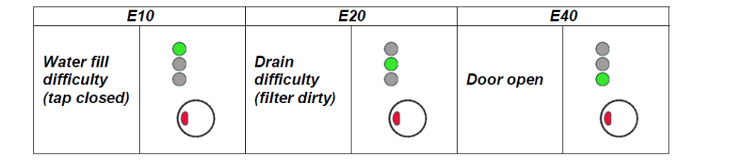

The aforementioned alarms (for both versions) can be remedied directly by the end user.
On the other hand, the alarms listed below (for both versions):
􀂪 EF0 – Water leakage (Aqua Control System)
􀂪 EH0 – Voltage or frequency outside the normal values

These are displayed to the user, but technical assistance is required to remedy them. Please contact After Sales to book an engineer.

